**Bountiful Foods Web Page – Jeremy Herrera WDD230**

**Site Purpose**

The website of Bountiful Foods serves as a digital marketplace where users may research and buy organic, regional delicacies. The company's website acts as the go-to resource for details about its Carlsbad shop, food trucks, and delivery services. The main objectives are to highlight the usage of organic products, encourage the consumption of fresh and nutritious food alternatives, and offer convenience to both locals and visitors to the coastal regions.

**Target Audience**

The target audience for Bountiful Foods' website includes:

- Health-conscious people looking for fresh and organic food alternatives.

- The inhabitants of Carlsbad as well as the Los Angeles to San Diego coastline region.

- Travelers looking for wholesome, regional cuisine while in coastal regions.

- People who value convenience and value fruit drinks and fruit bags that are created to order.

**Persona**

Persona 1: Health-conscious Individual – Lorena Arevalo

Age: 35

Occupation: Yoga instructor

Single, no children

Education: Certified nutritionist

Goals: Seeking fresh and organic food options, interested in supporting local businesses, looking for convenient and healthy meal options.

Persona 2: Tourist - Alicia Gatica

Age: 45

Occupation: Marketing executive

Married with two teenage children

Education: Master's degree in business administration

Goals: Exploring the coastal areas on vacation, interested in trying local and healthy cuisine, seeking convenient food options for the family.

**Scenarios**

Scenario 1: Lorena is looking for a nearby restaurant or food truck that sells a variety of organic fruits and veggies as well as made-to-order fruit cocktails. She wants to shop locally and find a quick method to get access to fresh food and nutritious snacks.

Scenario 2: Alicia wants to locate meal alternatives that fit his family's healthy lifestyle while they are on a trip. He's looking for neighborhood food trucks or delivery businesses that provide healthy, organic meal alternatives for the entire family.

**Site Map**

**Color** **Scheme**

The color scheme for the website should reflect the organic and fresh nature of the company:

- Primary Color: Deep green (#228B22)

- Secondary Color: Vibrant orange (#e98074)

- Accent Color: Soft brown (#f8f4e9)

These colors represent the idea of healthy eating, organic bounty, and convenience.

**Typography**

- Headings and titles: 'Open Sans', sans-serif

- Body text: 'Open Sans', sans-serif

The website will utilize the Open Sans font from the Google Fonts directory. Having outstanding readability and legibility, Open Sans is a simple and contemporary sans-serif typeface. It will be applied to every paragraph, header, and subheading in the website.

**Large View**

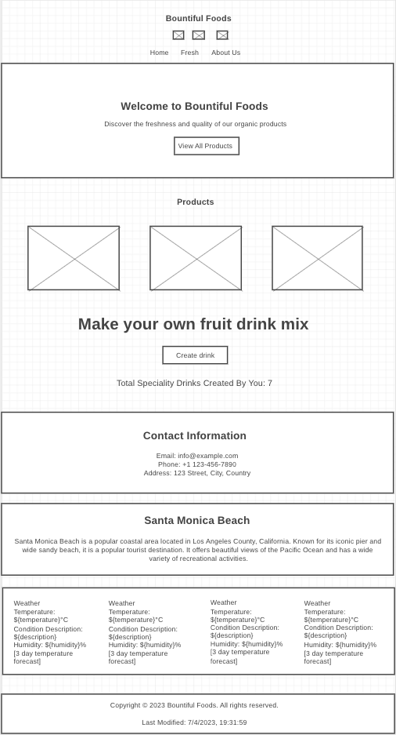

**Medium View**

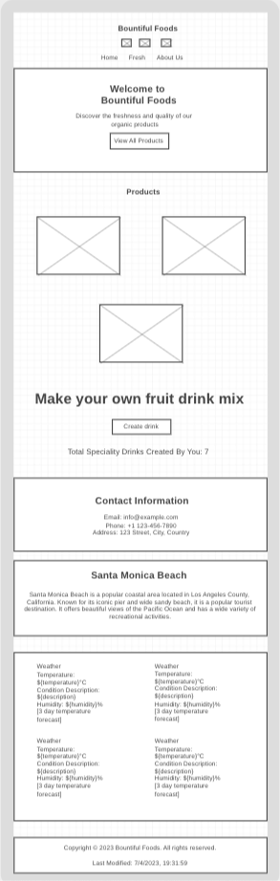

**Small View**

